**8**

**Conservation of Energy**

|  |
| --- |
| **CHAPTER OUTLINE** |

8.1 Analysis Model: Nonisolated System (Energy)

8.2 Analysis Model: Isolated System (Energy)

8.3 Situations Involving Kinetic Friction

8.4 Changes in Mechanical Energy for Nonconservative Forces

8.5 Power

* An asterisk indicates a question or problem new to this edition.

|  |
| --- |
| **SOLUTIONS TO THINK-PAIR-SHARE AND ACTIVITIES** |

**\*TP8.1 Conceptualize** Imagine the situation occurring: The car is moving up the hill and suddenly the brakes are slammed on, locking the wheels. The car slows down due to two effects: the kinetic friction force on the wheels, and a component of the gravitational force acting down the hill. Because the wheels are locked, the car leaves a nice long trail of the evidence of its motion on the street—the skid mark. We will assume that we can distinguish the skid marks from the front tires from those of the rear, so we do not need to know the distance between the front and rear wheels. Either set of skid marks is 17.0 m long. Let’s make a drawing of the situation:

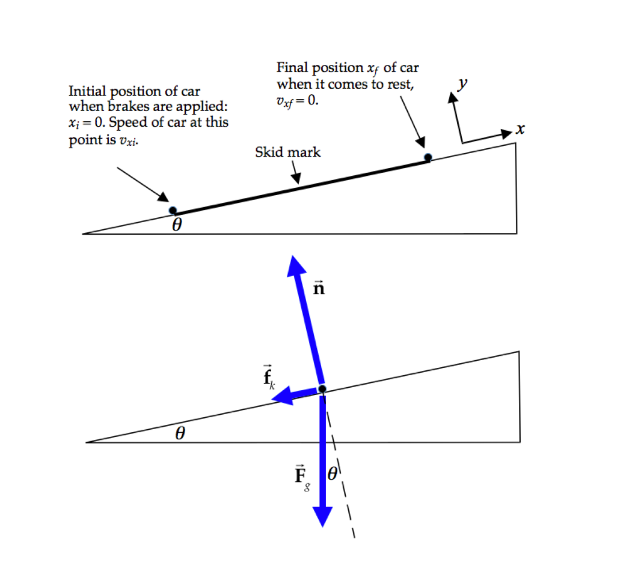

The upper drawing shows the kinematic information, while the lower drawing is a free-body diagram for the car during its motion.

**Categorize** The car is modeled as a *particle in equilibrium* in the direction perpendicular to the plane of the hill. The car, the Earth, and the hill together are modeled as an *isolated system* for *energy*, with a nonconservative force (friction) acting.

**Analyze** From the particle in equilibrium model, write an equation for the *y* direction, perpendicular to the plane:



Now, write Equation 8.2 for the system of the car, the Earth, and the hill:

 (2)

Incorporate Equation 8.14 to represent the change in internal energy of the system:

 (3)

where *d* is the distance that the car slides while coming to a stop. Express the friction force in terms of the normal force on the car and then substitute from Equation (1):

 (4)

Substitute for the initial and final energy values:



Solve for the initial speed of the car:

 (5)

Substitute numerical values:



**Finalize** This initial speed of the car exceeds the posted speed limit by over 50%, so your group should *not* agree to offer testimony for the defense in this case. Notice what data we did *not* need for a solution: the mass of the car, the mass of the driver, and the coefficient of static friction. Notice also that the Equation (5) is identical to Equation (7) in the solution to Think–Pair–Share Problem 5.1, where we used a force approach to solve the problem.

*Answer:* no

**\*TP8.2 Conceptualize** Wouldn’t it be great if we could operate our cars from the Sun? No more need for oil! Don’t get too excited, however. The problem is suggesting that this is *not* possible.

**Categorize** The car is acting as a *nonisolated system,* taking energy in by electromagnetic radiation from the Sun.

**Analyze** Imagine that the Sun is directly overhead (which only happens near the equator). Imagine that the entire upward-facing area of the car is covered by some type of panels that will transform 100% of the sunlight to energy available to make the car move. Let’s estimate the upward-facing area of a typical car is 2 m by 5 m = 10 m2. The power delivered to the car is



Using the definition of the horsepower in Section 8.5, let’s convert this power to horsepower:



**Finalize** This is a very small amount of power. A tiny, fuel-efficient, gasoline-powered car may have a horsepower rating of 70 hp. Furthermore, we have assumed 100% efficiency in transforming solar power to running the car. Current solar panels might be 15% efficient, reducing the power above to about 2 hp. Furthermore, cars operating far from the equator will receive light from the Sun at an angle to the vertical, reducing the intensity. And cars everywhere will have trouble with cloudy days! Calculations like these can be used in trial to show that, no matter how ingenious the inventor’s scheme may be, there simply isn’t enough energy delivered to a car by solar radiation to make it run.

*Answer:* For 100% efficient solar cells, energy arriving at car is only 13 hp.

**\*TP8.3** Below is a typical diagram for a house:

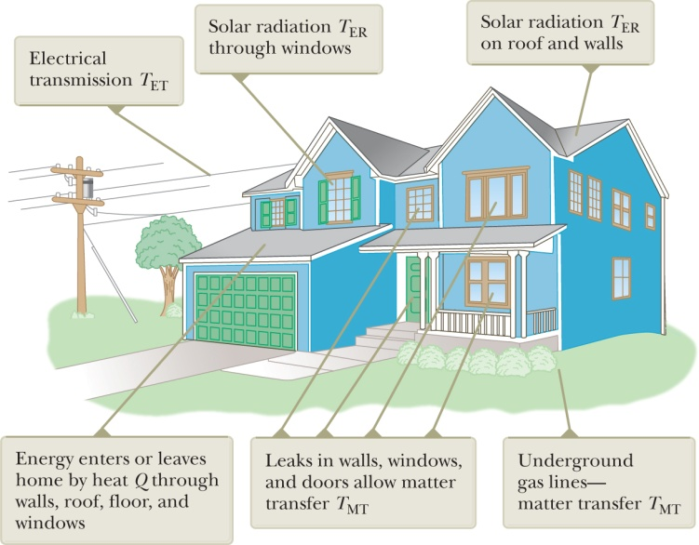

**[Fig. ANS TP8.3 ]**

(a) Heat *Q*: through walls, ceiling, floor, windows, doors; inward during summer, outward during winter. Matter transfer *T*MT: air flow through leaks around windows and doors, natural gas entering through gas lines, water entering through pipes and leaving through drains, air leaving via chimneys and exhaust vents. Electromagnetic radiation *T*ER: sunlight coming in windows, sunlight warming up exterior surfaces, home radiating outward at infrared frequencies, signals through radio, television, and cellphone broadcasts, or via optical fiber connections. Electrical transmission *T*ET: electrical energy entering house through power lines and being consumed by devices, electrical signals through telephone and cable connections.

(b) Heat *Q*: add insulation in walls and ceiling, install double-pane windows, use insulating curtains. Matter transfer *T*MT: seal leaks around windows and doors, replace gas appliances with those of higher efficiency. Electromagnetic radiation *T*ER: use solar glass in windows, close curtains to reflect light outdoors (or open curtains in winter to allow sunlight to warm the house), install solar panels to capture energy. Electrical transmission *T*ET: use compact fluorescent bulbs or LEDs, replace electrical devices with more efficient models, turn off lights when not being used, limit use of air conditioning.

(c) Insolation: *T*ER, Infiltration: *T*MT

*Answers:* Answers will vary.

**\*TP8.4 Conceptualize** Read Example 8.4 carefully. Now imagine that there is some friction between the projectile and the interior of the barrel. How do expect that friction force to affect the results?

**Categorize** We model the system of the projectile, the spring, the Earth, and the popgun as an *isolated system* within which a conservative force acts.

**Analyze** (a) Let’s follow the same procedure as in the solution to the example as far as we can. Write Equation 8.2 between configurations A and C:

 (1)

Substitute for the initial and final energies:

 (2)

In the example, we solved for the spring constant *k*. In this problem, we know the spring constant and are asked for the final height. So solve Equation (2) for *y*C:



Substitute numerical values, from Example 8.4 and the problem statement:



(b) Now let’s consider the energy bar charts for each of the situations exemplified by the bar charts in Example 8.4. We define the zeros of both gravitational potential energy and elastic potential energy as the configuration existing when the ball is at position B at the top of the uncompressed spring. There is clearly internal energy in the system, since it has a temperature, but we have no idea of its value. Let us therefore define an arbitrary zero of internal energy for the configuration of the system before the popgun is loaded, and consider changes in internal energy from that configuration.

Before the popgun is loaded, there is no energy in the popgun–Earth system: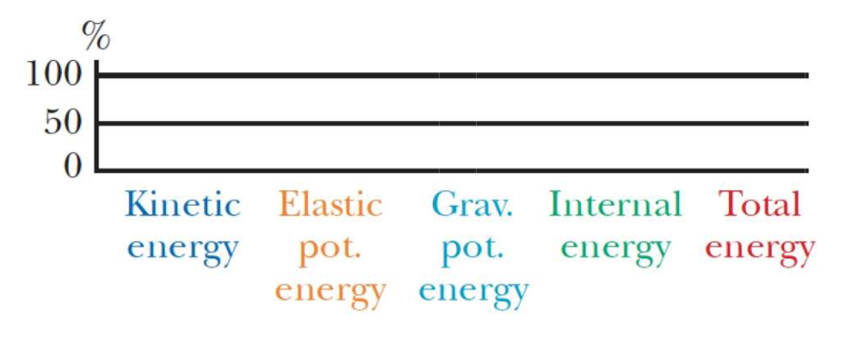

After the popgun is loaded, work has been done on the system, so there is a total energy in the system, the spring is compressed, so there is elastic potential energy in the spring, and the projectile is located below point B, so the gravitational potential energy is negative. In addition, there is a small increase in internal energy due to the friction of the projectile against the interior of the barrel as it was pushed downward:

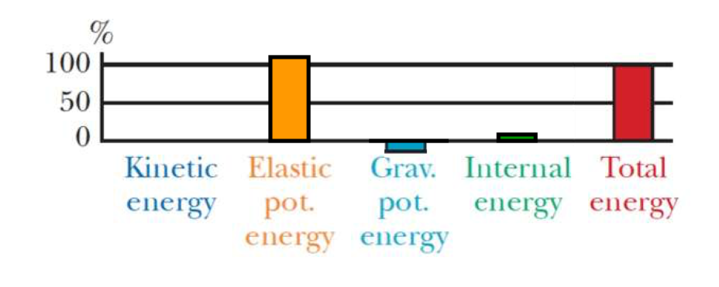

As the projectile passes through the point B, the system has gained kinetic energy because of the moving projectile and also gained more internal energy because of friction:

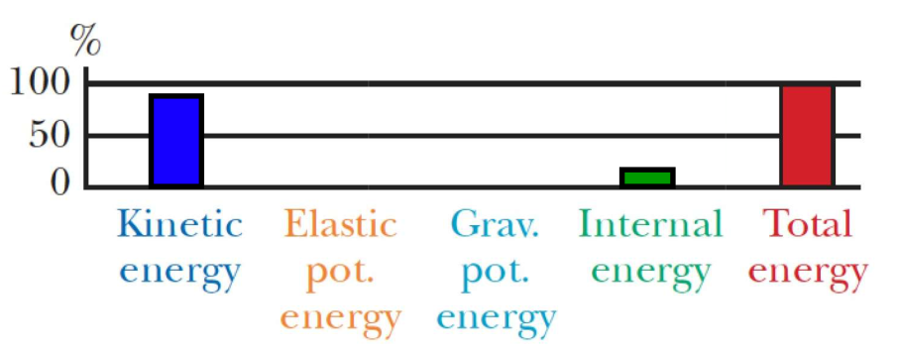

Finally, when the projectile reaches its highest point, the total energy is gravitational and internal:

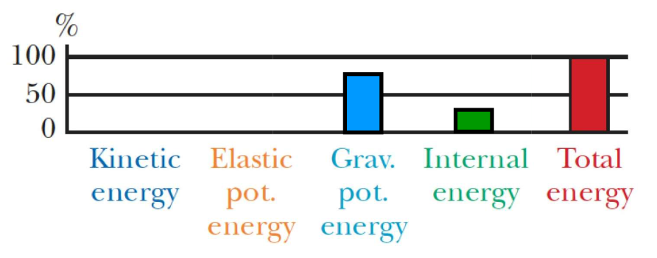

**Finalize** In Example 8.4, the projectile rose to 20.0 m, so the effect of friction in part (a) is to reduce the highest position of the projectile by 3.5 m.

*Answers:* (a) 16.5 m (b) See solution.

|  |
| --- |
| **SOLUTIONS TO END-OF-CHAPTER PROBLEMS** |

Section 8.1 Analysis Model: Nonisolated system (Energy)

P8.1 (a) The system of the ball and the Earth is isolated. The gravitational energy of the system decreases as the kinetic energy increases.







(b) The gravity force does positive work on the ball as the ball moves downward. The Earth is assumed to remain stationary, so no work is done on it.

∆*K* = *W*





**Section 8.2 Analysis Model: Isolated System (Energy)**

**P8.2** (a) 



We use the Pythagorean theorem to express the original kinetic energy in terms of the velocity components (kinetic energy itself does not have components):



Because v*xi =* v*xf* , we have



so for the first ball:



and for the second,



(b) The total energy of each ball-Earth system is constant with value



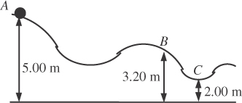**P8.3** (a) Define the system as the block and the Earth.

∆*K* + ∆*U* = 0

Ans. Fig. P8.3

  


Similarly,

  


(b) Treating the block as the system,



P8.4(a) One child in one jump converts chemical energy into mechanical energy in the amount that the child-Earth system has as gravitational energy when she is at the top of her jump:

*mgy* = (36 kg)(9.80 m/s2) (0.25 m) = 88.2 J

For all of the jumps of the children the energy is

 

(b) The seismic energy is modeled as



making the Richter magnitude

 

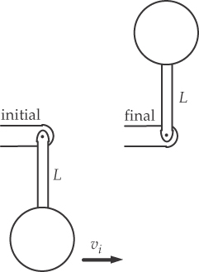P8.5 The force of tension and subsequent force of compression in the rod do no work on the ball, since they are perpendicular to each step of displacement. Consider energy conservation of the ball-Earth system between the instant just after you strike the ball and the instant when it reaches the top. The speed at the top is zero if you hit it just hard enough to get it there. We ignore the mass of the “light” rod.

Ans. Fig. P8.5

∆*K* + ∆*U* = 0:





P8.6 When block B moves up by 1 cm, block A moves down by 2 cm and the separation becomes 3 cm. We then choose the final point to be when B has moved up by  and has speed  Then A has moved down  and has speed v*A*:





**Section 8.3 Situations Involving Kinetic Friction**

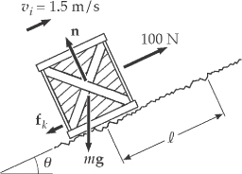P8.7 (a) The force of gravitation is

(10.0 kg)(9.80 m/s2) = 98.0 N

straight down, at an angle of

(90.0° + 20.0°) = 110.0°

Ans. Fig. P8.7

with the motion. The work done by the gravitational force on the crate is



(b) We set the *x* and *y* axes parallel and perpendicular to the incline, respectively.

From *=* *may* ,we have

*n* − (98.0 N) cos 20.0° = 0

so *n =* 92.1 N

and

*fk =* *μk n =* 0.400 (92.1 N) = 36.8 N

Therefore,



(c) 

(d) We use the energy version of the nonisolated system model.





The normal force does zero work, because it is at 90° to the motion.



(e) Again,  so







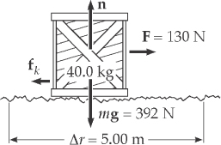P8.8 

(a) The applied force and the motion are both horizontal.

Ans. Fig. P8.8



(b) 

(c) Since the normal force is perpendicular to the motion,



(d) The gravitational force is also perpendicular to the motion, so



(e) We write the energy version of the nonisolated system model as





(f) 

P8.9 (a) 

(b) After N revolutions, the object comes to rest and *Kf* = 0.

Thus,



or



This gives



**Section 8.4 Changes in Mechanical Energy for Nonconservative Forces**

P8.10 (a) Apply conservation of energy to the bead-string-Earth system to find the speed of the bead at  Friction transforms mechanical energy of the system into internal energy 







For *yA* = 0.200 m, *fk* = 0.025 N, *d* = 0.600 m, and *m* = 25.0 × 10–3 kg:





(b) The red bead slides a greater distance along the curved path, so friction transforms more of the mechanical energy of the system into internal energy. There is less of the system’s original potential energy in the form of kinetic energy when the bead arrives at point  The result is that the green bead arrives at point  first and at higher speed.

P8.11(a) If only conservative forces act, then the total mechanical energy does not change.

∆*K +* ∆*U = 0* or *Uf = Ki – Kf + Ui*

*Uf* = 30.0 J – 18.0 J + 10.0 J = 



(b)  if the potential energy is less than 22.0 J.

(c) 

**P8.12** (a) The object drops distance *d* = 1.20 m until it hits the spring, then it continues until the spring is compressed a distance *x*.





Dropping units, we have



The negative root does not apply because *x* is a distance. We have



(b) This time, friction acts through distance (*x + d*)in the object-spring-Earth system:



where *mg – fk* = 14.0 N. Suppressing units, we have







The positive root is 

(c) On the Moon, we have





Suppressing units,







P8.13 (a)  


(b) 

(c) At the top of the water slide,

*U*g = *mgh* and *K* = 0: *E =* 0 + *mgh* → 

(d) At the launch point, her speed is *v*i, and height *h* = *h*/5:

*E* = *K* + *Ug*



(e) At her maximum airborne height, h = ymax:

E = m*v*2 + mgh = m(*v*xi2 + *v*yi2) + mgymax

E = m(*v*xi2 + 0) + mgymax *→* 

(f) E = mgh = m*v*i2 + mgh/5 → 

(g) At the launch point, her velocity has components *v*xi = *v*i cos*θ* and *v*yi = *v*i sin*θ* :







(h) 

P8.14 Air resistance acts like friction.Consider the whole motion:



(a) 



(b) 

(c) Now in the same energy equation as in part (a), *d*2 is unknown, and *d*1 = 1 000 m – *d*2:



(d) 

P8.15 **Conceptualize** The diagram below shows the two trails from the side. Each trail begins from the same height. The skier slides down a slope of length *d* and then along a flat of length *L* to arrive at the lodge. The horizontal separation between the initial and final points is shown as *r*.

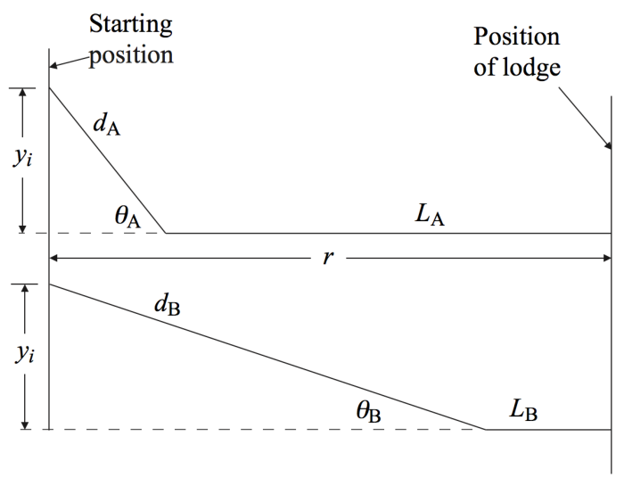

**Categorize** We define the system as the skier, the Earth, and the surface. This is an *isolated system* in which a nonconservative force acts.

**Analyze** Write the appropriate reduction of Equation 8.2 for this system as the skier slides down one of the slopes. For now, we will not identify which slope.

 (1)

Evaluate the energies between the starting position and the bottom of the angled part of the trail, and solve for *vb*, the speed of the skier at the bottom of the angled part of the trail:

 (2)

Evaluate the force of kinetic friction on the angled part of the trail, incorporating the particle in equilibrium model for the skier in a direction perpendicular to the slope:

 (3)

Substitute Equation (3) into Equation (2):

 (4)

Now write Equation 8.2 for this system as the skier coasts along one of the flat regions. There is no change in gravitational potential energy for this motion.

 (5)

Evaluate the energies between the bottom of the angled part of the trail and the lodge, and solve for *vf*, the speed with which the skier arrives at the lodge:

 (6)

Evaluate the force of kinetic friction on the flat part of the trail:

 (7)

Substitute Equation (7) into Equation (6):

 (8)

Substitute Equation (4) into Equation (8):

 (9)

Finally, notice the distance *r* in the figure. This is the horizontal distance between the starting point and the lodge, and is the same for both trails. From the geometry, notice that

 (10)

Solve Equation (10) for *d* cos **:

 (11)

Substitute into Equation (9):

 (12)

The expression on the right in Equation (12) contains only parameters that are the same for both trails: the initial height *yi* and the horizontal distance *r*. Therefore, it makes no difference which trail you take in terms of the speed with which you arrive at the lodge.

**Finalize** If we were to ask about which trail gets you to the lodge first, that’s a different question. What do you think about that question?

*Answer:* Both trails result in the same speed.

**Section 8.5 Power**

P8.16 (a) 

(b) 

P8.17 energy = power × time

For the 28.0-W bulb:

Energy used = (28.0 W)(1.00 × 104 h) = 280 kWh

total cost = $4.50 + (280 kWh)($0.200/kWh) = $60.50

For the 100-W bulb:

Energy used = (100 W)(1.00 × 104 h) = 1.00 × 103 kWh

# of bulbs used 

total cost = 13($0.420) + (1.00 × 103 kWh)($0.200/kWh) = $205.46

Savings with energy-efficient bulb:

$205.46 – $60.50 = $144.96 = 

P8.18 

older-model: *W* = *mv*2

newer-model: 



P8.19 A 1 300-kg car speeds up from rest to 55.0 mi/h *=* 24.6 m/s in 15.0 s. The output work of the engine is equal to its final kinetic energy,



with power  around 30 horsepower.

P8.20 **Conceptualize** The 120 Wh of energy is used to accelerate the scooter to its cruising speed and overcome friction between the wheels and the surface on which it rolls, as well as internal friction in the mechanisms of the scooter. When you are suddenly faced with an uphill climb, the battery must also provide energy to increase the gravitational potential energy of the scooter–Earth system

**Categorize** Identify the system of interest to be the scooter and the Earth. We can then apply the *isolated system* model for *energy*.

**Analyze** Write the appropriate reduction of Equation 8.2 for the test drive on flat ground:

 (1)

where ∆*E*int represents the warming up of the scooter, atmosphere, and roadway due to friction and other losses. Based on the reading on the battery indicator,

 (2)

Therefore, from Equation (1),

 (3)

Now write Equation 8.2 for the 5K event, which includes hills:

 (4)

Solve for the change in potential energy of the battery:

 (5)

Based on the final statement in the problem, the change in internal energy is the same as for the flat test drive. Therefore,



Substitute numerical values:



The energy depletion of the battery on the route with the hills is 109 Wh and, therefore, less than the available energy of 120 Wh. Therefore, your grandmother can accompany you!

**Finalize** The energy requirement is a relatively large fraction of the

available energy, 91%. Therefore, you might be a little nervous on this trip. How likely is it that the change in internal energy is the same for a flat trip and a trip uphill? And then how do you get your grandmother all the way back to where you parked your car? You might want to invest in a replacement battery to be safe.

*Answer:* Your grandmother can accompany you.

**P8.21** (a) The fuel economy for walking is



(b) For bicycling:



P8.22 (a) Burning 1 kg of fat releases energy



The mechanical energy output is



where *n* is the number of flights of stairs. Then





where the number of times she must climb the stairs is



(b) Her mechanical power output is



(c) 

**Additional Problems**

P8.23(a) Let us take *U* = 0 for the particle-bowl-Earth system when the particle is at . Since *vB =* 1.50 m/s and *m =* 200 g,



(b) At , *vi =* 0, *KA =* 0, and the whole energy at  is *UA =* *mgR*:

**

At ,

*Ef* = *KB + UB* = 0.225 J + 0

The decrease in mechanical energy is equal to the increase in internal energy.

**

The energy transformed is

**

(c) 

(d) 

**P8.24** At a pace I could keep up for a half-hour exercise period, I climb two stories up, traversing forty steps each 18 cm high, in 20 s. My output work becomes the final gravitational energy of the system of the Earth and me,



making my sustainable power .

**P8.25 Conceptualize** Consider Figure 8.10, associated with Example 8.7. This diagram shows a simple case of an object sliding down a track. The present problem is similar except for the following: The track is undulating, rather than straight, the friction force changes near the end of the motion, and, of course, the ride is much taller than the back of the pickup truck!

**Categorize** Identify the system as the car, the track, and the Earth. We will ignore any sound made by the system, so we use the *isolated system* model in which a nonconservative force acts.

**Analyze** (a) Write the appropriate reduction of Equation 8.2 for the system:

 (1)

The time interval will be that associated with the motion of the car through the final section of track length 250 m. The change in internal energy will consist of two parts, representing the two sections of the track over which different friction forces act. Therefore,

 (2)

Combining Equations (1) and (2), we have

 (3)

Solve Equation (3) for the unknown friction force *fk*,2:

 (4)

Substitute for the initial and final energies:

 (5)

Substitute numerical values:



(b) Because the last 20 m of track are at ground level, the highest speed will occur just at the end of the 230-m section of track. For this section of track, Equation (3) becomes

 (6)

Substitute for the initial and final energies and solve for the final speed:

 (7)

Substitute numerical values:



(c) The new total mass of the car is 250 kg + 450 kg = 700 kg. Substitute this new mass into Equations (5) and (7):





(d) Rearrange Equation (7) and solve for the height of the track *above the lowest point*:

 (8)

Substitute numerical values:



With 110 m of height above the ground, the depth of the underground portion must be 155 m – 110 m = 45 m.

(e) In part (d), a 45-m-deep underground portion is a major undertaking and would probably be cost-prohibitive. In addition, let’s look at the lengths of track. There is a 155-m vertical drop from highest point to lowest point. Then there is another vertical 45 m required to come back up to ground level. At ground level, there is a flat 20-m section. These lengths add to 155 m + 45 m + 20 m = 220 m. The total length of track is claimed to remain at 230 m in part (d). Therefore, there is only 10 m of track remaining to account for all the *curves* in the track: the 155-m, 45-m, and 20-m distances are all straight vertical and horizontal lines! This would suggest that this construction is not feasible.

**Finalize** Notice in part (c) that the speed does not vary much between the

loaded and unloaded car. In fact, if the track were frictionless, the speed would

be the same for all masses.

*Answers:* (a) 1.29 × 104 N (b) 45.4 m/s (c) 3.72 × 104 N ; 46.1 m/s (d) 45 m (e) no

P8.26 (a) Mechanical energy is conserved in the two blocks-Earth system:



(b) For the 3.50-kg block from when the string goes slack until just before the block hits the floor, conservation of energy gives



2.49 m/s

(c) The 3.50-kg block takes this time in flight to the floor: from *y* *=* (1/2)*gt*2 we have *t* *=* [2(1.2)/9.8]1/2 *=* 0.495 s. Its horizontal component of displacement at impact is then

*x* = *vd t* = (2.49 m/s)(0.495 s) = 

(d) 

(e) 

**P8.27** (a) The block-spring-surface system is isolated with a nonconservative force acting. Therefore, Equation 8.2 becomes





To find the maximum speed, differentiate the equation with respect to *x*:



Now set *dv*/*dx* = 0:



This is the compression distance of the spring, so the position of the block relative to *x* = 0 is 

(b) By the same approach,

 so the position of the block is 

P8.28 The distance traveled by the ball from the top of the arc to the bottom is *πR*. The change in internal energy of the system due to the nonconservative force, the force exerted by the pitcher, is



We shall assign the gravitational energy of the ball-Earth system to be zero with the ball at the bottom of the arc.

Then



becomes



Solve for R, which is the length of her arms.





P8.29 (a) The total external work done on the system of Jonathan-bicycle is



(b) Gravity does work on the Jonathan-bicycle system, and the potential (chemical) energy stored in Jonathan’s body is transformed into kinetic energy:



(c) Jonathan does work on the bicycle (and his mass). Treat his work as coming from outside the bicycle-Jonathan’s mass system:



P8.30 (a) The total external work done on the system of Jonathan-bicycle is



(b) Gravity does work on the Jonathan-bicycle system, and the potential (chemical) energy stored in Jonathan’s body is transformed into kinetic energy:



(c) Jonathan does work on the bicycle (and his mass). Treat his work as coming from outside the bicycle-Jonathan’s mass system:



P8.31 (a) To calculate the change in kinetic energy, we integrate the expression for *a* as a function of time to obtain the car’s velocity:



At *t* = 0, *vi* = 0. At *t* = 2.5 s,



The change in kinetic energy during this interval is then



(b) The road does work on the car when the engine turns the wheels and the car moves. The engine and the road together transform chemical potential energy in the gasoline into kinetic energy of the car.





(c) 

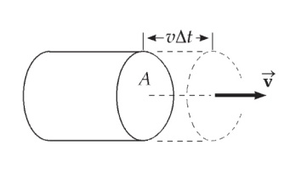P8.32 

The density is 

Ans. Fig. P8.32

Substituting this into the first equation and solving for P, since  for a constant speed, we get



Also, since *P* = *Fv*,





P8.33 (a) Simplified, the equation is

0 = (9700 N/m)*x*2 – (450.8 N)*x* – 1395 N ⋅ m

Then



(b) 

(c) 

(d) 

P8.34 At the bottom of the circle, the initial speed of the coaster is 22.0 m/s. As the coaster travels up the circle, it will slow down. At the top of the track, the centripetal acceleration must be at least that of gravity, g, to remain on the track. Apply conservation of energy to the roller coaster-Earth system to find the speed of the coaster at the top of the circle so that we may find the centripetal acceleration of the coaster.





For this speed, the centripetal acceleration is





P8.35 (a) The energy stored in the spring is the elastic potential energy,   
*U* = *kx*2, where *k* = 850 N/m. At *x* = 6.00 cm,

*U* = *kx*2 = (850 N/m)(0.0600 m)2 = 

At the equilibrium position, *x* = 0, .

(b) Applying energy conservation to the block-spring system:



because the block is released from rest. For *xf* = 0, *U* = 0, and



(c) From (b) above, for *xf* = *xi*/2 = 3.00 cm,

*U* = *kx*2 = (850 N/m)(0.0300 m)2 = 0.383 J

**P8.36** (a) The suggested equation  implies all of the following cases:

(1) 

(2) 

(3)  and

(4) 

These are all of the proportionalities Aristotle lists.

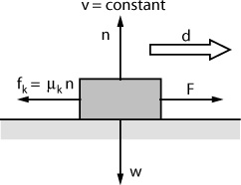

Ans Fig. P8.36

(b) 

 implies that

+*n* – *w* = 0 and *F* – *µkn* = 0

so that *F* = *µkw.*

As the object moves a distance *d*, the agent exerting the force does work



and puts out power 

This yields the equation  which represents Aristotle’s theory with 

Our theory is more general than Aristotle’s. Ours can also describe accelerated motion.

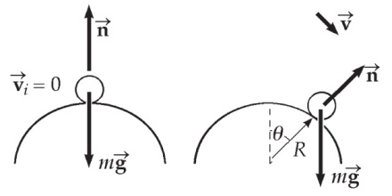**P8.37** *m* = mass of pumpkin

*R* = radius of silo top

Ans. Fig. P8.37



When the pumpkin first loses contact with the surface, *n* = 0.

Thus, at the point where it leaves the surface: 

Choose *Ug* = 0 in the *θ* = 90.0° plane. Then applying conservation of energy for the pumpkin-Earth system between the starting point and the point where the pumpkin leaves the surface gives



Using the result from the force analysis, this becomes

, which reduces to

, and gives 

as the angle at which the pumpkin will lose contact with the surface.

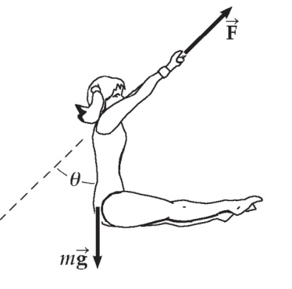**P8.38** The force needed to hang on is equal to the force *F* the trapeze bar exerts on the performer. From the free-body diagram for the performer’s body, as shown,



Ans. Fig. P8.38

or 

At the bottom of the swing, *θ* = 0°, so



The performer cannot sustain a tension of more than 1.80*mg*. What is the force *F* at the bottom of the swing? To find out, apply conservation of mechanical energy of the performer-Earth system as the performer moves between the starting point and the bottom:



Hence,  at the bottom.



**P8.39** (a)  The system of the airplane and the surrounding air is nonisolated. There are two forces acting on the plane that move through displacements, the thrust due to the engine (acting across the boundary of the system) and a resistive force due to the air (acting within the system). Since the air resistance force is nonconservative, some of the energy in the system is transformed to internal energy in the air and the surface of the airplane. Therefore, the change in kinetic energy of the plane is less than the positive work done by the engine thrust. So, 

(b) Since the plane is in level flight,  and the conservation of energy for nonisolated systems reduces to



or





This gives





**P8.40** (a) Energy is conserved in the swing of the pendulum, and the stationary peg does no work. So the ball’s speed does not change when the string hits or leaves the peg, and the ball swings equally high on both sides.

(b) The ball will swing in a circle of radius *R =* (*L – d*) about the peg. If the ball is to travel in the circle, the minimum centripetal acceleration at the top of the circle must be that of gravity:



When the ball is released from rest, *Ui* = *mgL*, and when it is at the top of the circle, *Ui* = *mg*2(*L – d*), where height is measured from the bottom of the swing. By energy conservation,



From this and the condition on *v2* we find .

and



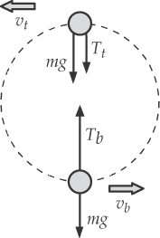**P8.41** Applying Newton’s second law at the bottom (*b*) and top (*t*) of the circle gives

Ans. Fig. P8.41

 and 

Adding these gives



Also, energy must be conserved and 

So,  and 

Substituting into the above equation gives .

**\*P8.42 Conceptualize** The more packages loaded onto the belt per unit time, the more energy per unit time is required from the driving motor, since it must accelerate each package up to the speed of the belt.

**Categorize** We identify the system of *N* packages and the conveyor belt as a *nonisolated system* for *energy*.

**Analyze** Write the appropriate reduction of Equation 8.2 for the system:

 (1)

The first terms represents the fact that the packages are placed on the belt with zero kinetic energy and then accelerate to the speed of the belt. The second term represents the fact that the packages will slide on the belt until they reach the speed of the belt, so that friction will transform energy to internal energy. The work *W* on the right is that done by the motor.

While one package is sliding just after being placed on the belt, it is accelerated in the horizontal direction by the friction force. Because this is a kinetic friction force, its magnitude is

 (2)

where we have used the particle in equilibrium model for the package in the vertical direction to find that *n* = *mg*. From Newton’s second law applied in the horizontal direction to the package, we can find the acceleration of the package:

 (3)

Because the coefficient of friction and the acceleration due to gravity are constant, the package can be modeled as a particle under constant acceleration. Using Equation 2.17 for the motion of the package along the belt while it is sliding, we find

 (4)

where *d*package is the distance the package moves, relative to the floor of the factory, until it reaches the speed *v* of the belt. Substitute Equation (3) into Equation (4):

 (5)

From Equation 2.13, we can find the time at which the package comes to rest on the belt, measured from *t* = 0 when the package is dropped onto the belt:



Now, from the particle under constant velocity model (Eq. 2.7), the point on the belt at which the package is first dropped moves the following distance in that time interval:

 (6)

Therefore, the distance over which the package slides on the belt is

 (7)

Now, use Equation 8.14 to find the increase in internal energy due to the sliding of one package on the belt:

 (8)

Substitute Equations (2) and (7) into Equation (8):

 (9)

We find the interesting result that the increase in internal energy in the system for one package is equal to the final kinetic energy of the package! Half the energy from the motor for each package goes into kinetic energy and half into internal energy.

Now evaluate the work in Equation (1) for *N* packages using the result of Equation (7):

 (10)

Differentiate Equation (10) with respect to time to find the power required by the motor, or the rate at which work must be done on the belt:

 (11)

Substitute numerical values:



**Finalize** Notice that we could solve this problem without having information that you may have thought was needed. For example, we don’t know the coefficient of friction between a package and the belt. We don’t know *d*, the distance the package slides on the belt before reaching the belt speed. We don’t know the time interval required for the package to reach the belt speed. None of these pieces of information are necessary.

The result we found is the power requirement only to bring the packages up to

the speed of the belt. It does not include power requirements for overcoming

friction forces within the mechanism of the belt and its driving motor. That

requirement would need to be estimated separately.

*Answer:* 456 W

**P8.43** (a) As at the end of the process analyzed in Example 8.8, we begin with a 0.800-kg block at rest on the end of a spring with stiffness constant 50.0 N/m, compressed 0.092 4 m. The energy in the spring is (1/2)(50 N/m)(0.092 4 m)2 = 0.214 J. To push the block back to the unstressed spring position would require work against friction of magnitude 3.92 N (0.092 4 m) = 0.362 J.



(b) The block approaches the spring with energy



It travels against friction by equal distances in compressing the spring and in being pushed back out, so half of the initial kinetic energy is transformed to internal energy in its motion to the right and the rest in its motion to the left. The spring must possess one-half of this energy at its maximum compression:



so *x* = 0.107 m

For the compression process we have the conservation of energy

equation



so 

As a check, the decompression process is described by



which gives the same answer for the coefficient of friction.

**Challenge Problems**

**P8.44** (a) 

(b) At the original height and at all heights above 65.0 m – 25.8 m = 39.2 m, the cord is unstretched and . Below 39.2 m, the cord extension *x* is given by *x* = 39.2 m – *y*, so the elastic energy is



(c) For *y* > 39.2 m, 

For 



(d) See the graph in ANS. FIG. P8.44(d) below.

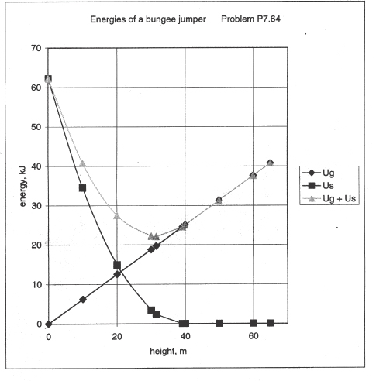

**ANS. FIG. P8.44(d)**

(e) At minimum height, the jumper has zero kinetic energy and the system has the same total energy as it had when the jumper was at his starting point.  becomes



Suppressing units,



(f) The total potential energy has a minimum, representing a  position. To find it, we require 

Suppressing units, we get



(g) Maximum kinetic energy occurs at minimum potential energy. Between the takeoff point and this location, we have



Suppressing units,



**P8.45** (a) Let *m* be the mass of the whole board. The portion on the rough surface has mass *mx/L*. The normal force supporting it is  and the friction force is  Then



(b) In an incremental bit of forward motion *dx*, the kinetic energy converted into internal energy is  The whole energy converted is



**P8.46** (a) Let mass *m*1 of the chain laying on the table and mass *m*2 hanging off the edge. For the hanging part of the chain, apply the particle in equilibrium model in the vertical direction:

*m*2*g* – *T* = 0 **[1]**

For the part of the chain on the table, apply the particle in equilibrium model in both directions:

*n* – *m*1*g* = 0 **[2]**

*T* – *fs* = 0 **[3]**

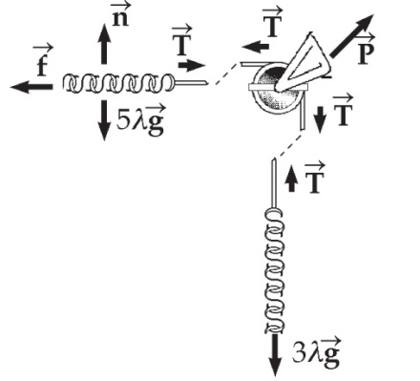 Assume that the length of chain   
hanging over the edge is such that   
the chain is on the verge of slipping.   
Add equations [1] and [3], impose   
the assumption of impending   
motion, and substitute equation [2]:

ANS. FIG. P8.46



From the total length of the chain of 8.00 m, we see that



where *λ* is the mass of a one meter length of chain. Substituting for *m*2,



From this result, we find that  and we see that 3.00 m of chain hangs off the table in the case of impending motion.

(b) Let *x* represent the variable distance the chain has slipped since the start.

Then length (5 – *x*) remains on the table, with now





Consider energies of the chain-Earth system at the initial moment when the chain starts to slip, and a final moment when *x* = 5, when the last link goes over the brink. Measure heights above the final position of the leading end of the chain. At the moment the final link slips off, the center of the chain is at *y*f = 4 meters.

Originally, 5 meters of chain is at height 8 m and the middle of the dangling segment is at height 

****: 



**P8.47** The coaster-Earth system is isolated as the coaster travels up the circle. Find how high the coaster travels from the bottom:



For this situation, the coaster stops at height 11.5 m, which is lower than the height of 24 m at the top of the circular section; in fact, it is close to halfway to the top. The passengers will be supported by the normal force from the backs of their seats. Because of the usual position of a seatback, there may be a slight downhill incline of the seatback that would tend to cause the passengers to slide out. Between the force the passengers can exert by hanging on to a part of the car and the friction between their backs and the back of their seat, the passengers should be able to avoid sliding out of the cars. Therefore, this situation is less dangerous than that in the original higher-speed situation, where the coaster is upside down.

|  |
| --- |
| **ANSWERS TO QUICK-QUIZZES** |

**1.** (i) (b) (ii) (b) (iii) (a)

**2.** (a)

**3.** *v1 = v2 = v3*

**4.** (c)

|  |
| --- |
| **ANSWERS TO EVEN-NUMBERED PROBLEMS** |

**P8.2** (a) 1.85 × 104 m, 5.10 × 104 m; (b) 1.00 × 107 J

**P8.4** (a) 1.11 × 109 J; (b) 0.2

**P8.6** (a) 22.0 J, 40.0 J (b) Yes (c) The total mechanical energy has decreased, so a nonconservative force must have acted.

**P8.8** (a) 650 J; (b) 588 J; (c) 0; (d) 0; (e) 62.0 J; (f) 1.76 m/s

**P8.10** (a) *v*B = 1.65 m/s2; (b) green bead, see P8.20 for full explanation

**P8.12** (a) 0.381 m; (b) 0.371 m; (c) 0.143 m

**P8.14** (a) 24.5 m/s; (b) Yes. This is too fast for safety; (c) 206 m; (d) see P8.14(d) for full explanation

**P8.16** (a) 8.01 W; (b) see P8.16(b) for full explanation

**P8.18** The power of the sports car is four times that of the older-model car.

**P8.20** 194 m

**P8.22** (a) 854; (b) 0.182 hp; (c) This method is impractical compared to limiting food intake.

**P8.24** ~102 W

**P8.26** (a) 2.49 m/s; (b) 5.45 m/s; (c) 1.23 m; (d) no; (e) Some of the kinetic energy of *m*2 is transferred away as sound and to internal energy in *m*1 and the floor.

**P8.28** We find that her arms would need to be 1.36 m long to perform this task. This is significantly longer than the human arm.

**P8.30** (a) ; (b) ; (c) 

**P8.32** ; ; see P8.32 for full explanation

**P8.34** Unrestrained passengers will fall out of the cars

**P8.36** (a) See P8.36(a) for full explanation; (b) see P8.36(b) for full explanation

**P8.38** The tension at the bottom is greater than the performer can withstand.

**P8.40** 

**P8.42** 456 W

**P8.44** (a) (627 N)*y*; (b) U*s* = 0, ; (c) (627 N)*y*,   
(40.5 N/m) *y*2 – (2 550 N)*y* + 62 200 J; (d) See ANS. FIG. P7.44(d);   
(e) 10.0 m; (f) stable equilibrium, 31.5 m; (g) 24.1 m/s

**P8.46** (a)  (b) 7.42 m/s